WEEK 3

Aim
To design and develop a Student Name Manager using HTML, CSS, and JavaScript to dynamically add and delete student names from a list and display the total number of students.

Description:
This experiment involves creating a Student Name Manager web application that allows users to enter and manage student names dynamically. The application provides an input field and an Add Student button to add student names to the list. Each student is displayed with a Delete button, which allows the corresponding student to be removed from the list.
The total number of students is automatically updated whenever a student is added or deleted. HTML is used to create the webpage structure, CSS is used to provide styling and layout, and JavaScript is used to implement dynamic add, delete, and student-count functionality.

Program code:
<!DOCTYPE html>
<html lang="en">
<head>
<meta charset="UTF-8">
<meta name="viewport" content="width=device-width, initial-scale=1.0">
<title>Student Name Manager</title>

<style>
body {
font-family: Arial, sans-serif;
background-color: #f5f5f5;
}

.container {
width: 650px;
margin: 30px auto;
padding: 25px;
background-color: white;
border-radius: 10px;
box-shadow: 0 3px 15px gray;
}

h1 {
font-size: 36px;
margin-bottom: 30px;
}

.input-area {
display: flex;
gap: 12px;
}

input {
flex: 1;
padding: 14px;
font-size: 16px;
}

button {
padding: 12px 20px;
font-size: 16px;
cursor: pointer;
}

#studentList {
margin-top: 20px;
}

.student {
display: flex;
justify-content: space-between;
align-items: center;

background-color: #eeeeff;
padding: 12px;
margin-bottom: 10px;
border-radius: 6px;

font-size: 20px;
}

.delete-btn {
background-color: #e05252;
color: white;
border: none;
padding: 9px 15px;
}

.delete-btn:hover {
background-color: #c93636;
}
</style>
</head>

<body>

<div class="container">

<h1>Student Name Manager</h1>

<div class="input-area">
<input
type="text"
id="studentName"
placeholder="Enter student name"
>

<button onclick="addStudent()">Add Student</button>
</div>

<h2>Total Students: <span id="total">0</span></h2>

<div id="studentList"></div>

</div>

<script>

let students = [];

function addStudent() {

let name = document.getElementById("studentName").value;

if (name.trim() === "") {
alert("Please enter student name");
return;
}

students.push(name);

document.getElementById("studentName").value = "";

displayStudents();
}

function displayStudents() {

let list = document.getElementById("studentList");

list.innerHTML = "";

students.forEach(function(student, index) {

let div = document.createElement("div");

div.className = "student";

div.innerHTML =
"<span>" + (index + 1) + ". " + student + "</span>" +
"<button class='delete-btn' onclick='deleteStudent(" +
index +
")'>Delete</button>";

list.appendChild(div);

});

document.getElementById("total").innerText = students.length;
}

function deleteStudent(index) {

students.splice(index, 1);

displayStudents();
}
</script>
</body>
</html>
Output:
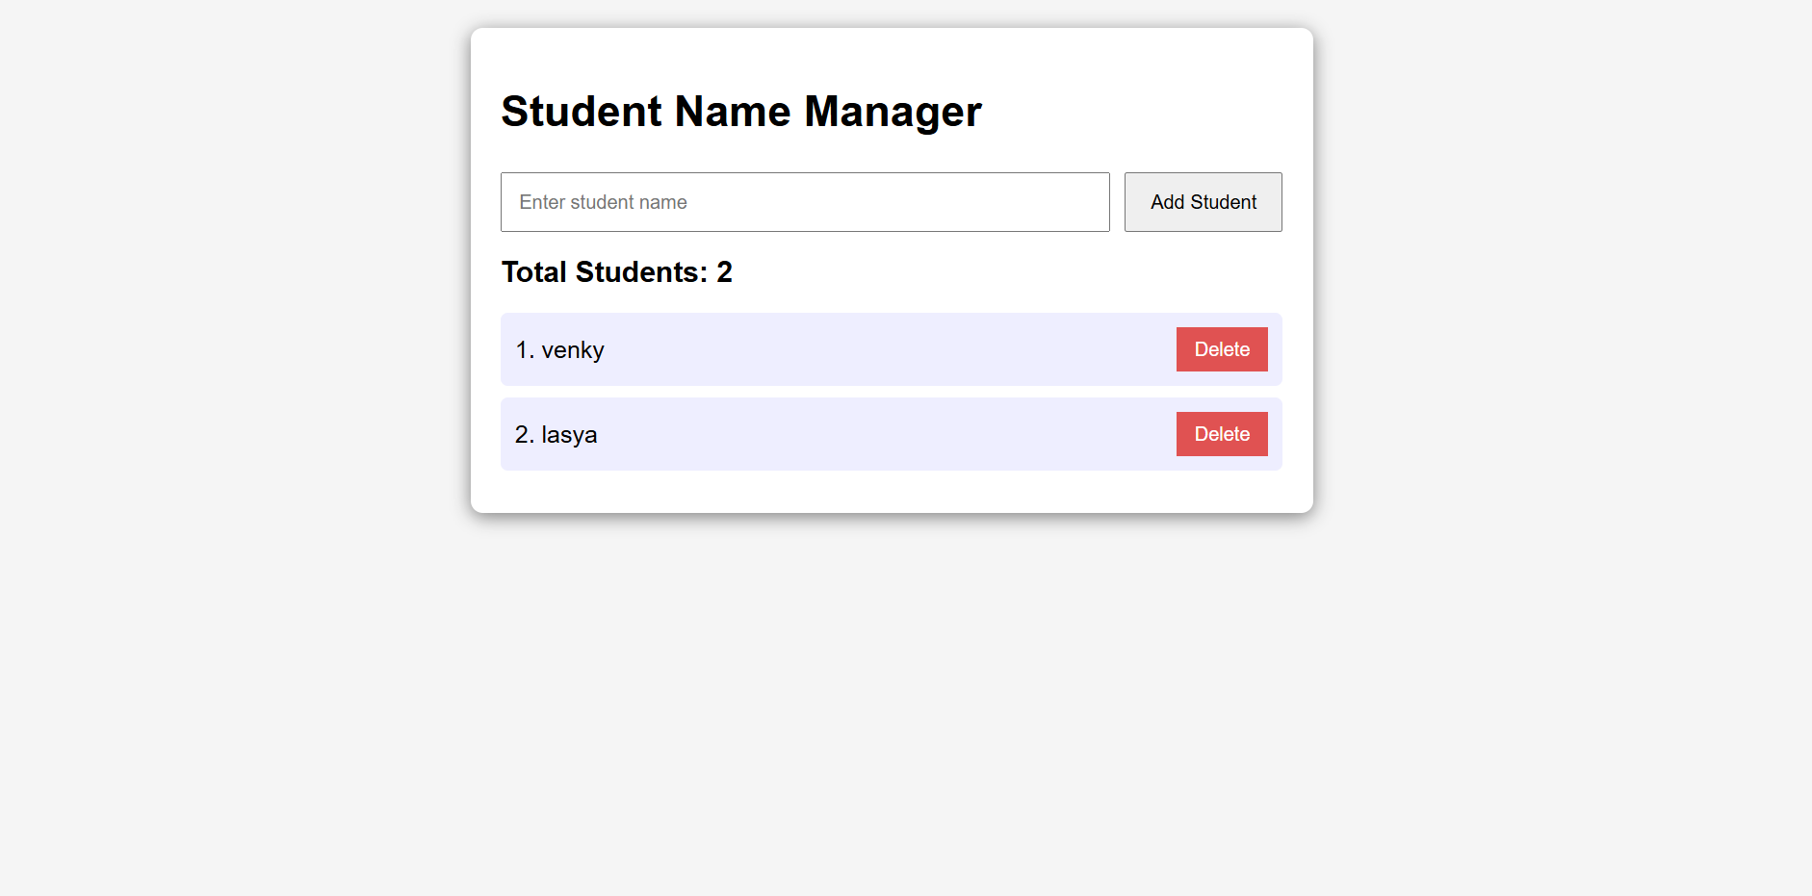
Result:
The Student Name Manager was successfully developed using HTML, CSS, and JavaScript. The application allows users to add and delete student names dynamically, while automatically updating and displaying the total number of students.

